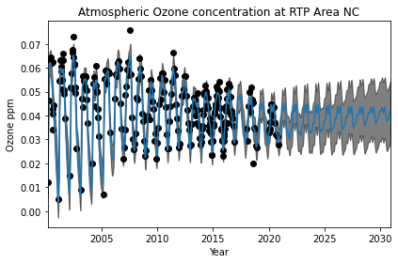

GPML kernel: 66**2 * RBF(length_scale=67) + 2.4**2 * RBF(length_scale=90) * ExpSineSquared(length_scale=1.3, periodicity=1) + 0.66**2 * RationalQuadratic(alpha=0.78, length_scale=1.2) + 0.18**2 * RBF(length_scale=0.134) + WhiteKernel(noise_level=0.0361)

Log-marginal-likelihood: -475.750

C:\Users\eveba\.conda\envs\Machine_Learning\lib\site-packages\sklearn\gaussian_process\kernels.py:402: ConvergenceWarning: The optimal value found for dimension 0 of parameter k1__k1__k1__k1__constant_value is close to the specified lower bound 1e-05. Decreasing the bound and calling fit again may find a better value.

warnings.warn("The optimal value found for "

C:\Users\eveba\.conda\envs\Machine_Learning\lib\site-packages\sklearn\gaussian_process\kernels.py:411: ConvergenceWarning: The optimal value found for dimension 0 of parameter k1__k1__k1__k2__length_scale is close to the specified upper bound 100000.0. Increasing the bound and calling fit again may find a better value.

warnings.warn("The optimal value found for "

Learned kernel: 0.00316**2 * RBF(length_scale=1e+05) + 1**2 * RBF(length_scale=7.32) * ExpSineSquared(length_scale=0.657, periodicity=0.996) + 0.241**2 * RationalQuadratic(alpha=1.05e+04, length_scale=1.24) + 0.231**2 * RBF(length_scale=0.065) + WhiteKernel(noise_level=0.127)

Log-marginal-likelihood: -192.878

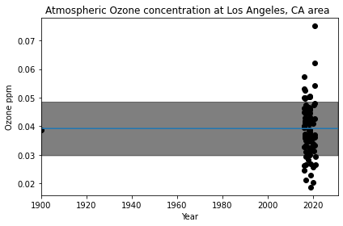

GPML kernel: 66**2 * RBF(length_scale=67) + 2.4**2 * RBF(length_scale=90) * ExpSineSquared(length_scale=1.3, periodicity=1) + 0.66**2 * RationalQuadratic(alpha=0.78, length_scale=1.2) + 0.18**2 * RBF(length_scale=0.134) + WhiteKernel(noise_level=0.0361)

Log-marginal-likelihood: -577.215

Learned kernel: 0.00316**2 * RBF(length_scale=5.6e+04) + 0.599**2 * RBF(length_scale=9.78e+03) * ExpSineSquared(length_scale=1e-05, periodicity=0.00841) + 0.00316**2 * RationalQuadratic(alpha=14.9, length_scale=1.05) + 0.00316**2 * RBF(length_scale=2.29e+04) + WhiteKernel(noise_level=0.659)

Log-marginal-likelihood: -122.651

C:\Users\eveba\.conda\envs\Machine_Learning\lib\site-packages\sklearn\gaussian_process\kernels.py:402: ConvergenceWarning: The optimal value found for dimension 0 of parameter k1__k1__k1__k1__constant_value is close to the specified lower bound 1e-05. Decreasing the bound and calling fit again may find a better value.

warnings.warn("The optimal value found for "

C:\Users\eveba\.conda\envs\Machine_Learning\lib\site-packages\sklearn\gaussian_process\kernels.py:402: ConvergenceWarning: The optimal value found for dimension 0 of parameter k1__k1__k2__k2__length_scale is close to the specified lower bound 1e-05. Decreasing the bound and calling fit again may find a better value.

warnings.warn("The optimal value found for "

C:\Users\eveba\.conda\envs\Machine_Learning\lib\site-packages\sklearn\gaussian_process\kernels.py:402: ConvergenceWarning: The optimal value found for dimension 0 of parameter k1__k2__k1__constant_value is close to the specified lower bound 1e-05. Decreasing the bound and calling fit again may find a better value.

warnings.warn("The optimal value found for "

C:\Users\eveba\.conda\envs\Machine_Learning\lib\site-packages\sklearn\gaussian_process\kernels.py:402: ConvergenceWarning: The optimal value found for dimension 0 of parameter k2__k1__k1__constant_value is close to the specified lower bound 1e-05. Decreasing the bound and calling fit again may find a better value.

warnings.warn("The optimal value found for "

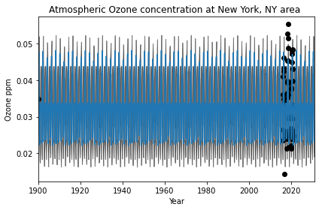

GPML kernel: 66**2 * RBF(length_scale=67) + 2.4**2 * RBF(length_scale=90) * ExpSineSquared(length_scale=1.3, periodicity=1) + 0.66**2 * RationalQuadratic(alpha=0.78, length_scale=1.2) + 0.18**2 * RBF(length_scale=0.134) + WhiteKernel(noise_level=0.0361)

Log-marginal-likelihood: -88.644

<ipython-input-3-a763a0186a3d>:37: DtypeWarning: Columns (8) have mixed types.Specify dtype option on import or set low_memory=False.

newX, newy = Ozone_prep()

C:\Users\eveba\.conda\envs\Machine_Learning\lib\site-packages\sklearn\gaussian_process\kernels.py:402: ConvergenceWarning: The optimal value found for dimension 0 of parameter k1__k1__k1__k1__constant_value is close to the specified lower bound 1e-05. Decreasing the bound and calling fit again may find a better value.

warnings.warn("The optimal value found for "

C:\Users\eveba\.conda\envs\Machine_Learning\lib\site-packages\sklearn\gaussian_process\kernels.py:411: ConvergenceWarning: The optimal value found for dimension 0 of parameter k1__k1__k1__k2__length_scale is close to the specified upper bound 100000.0. Increasing the bound and calling fit again may find a better value.

warnings.warn("The optimal value found for "

Learned kernel: 0.00316**2 * RBF(length_scale=1e+05) + 0.958**2 * RBF(length_scale=7.77e+03) * ExpSineSquared(length_scale=0.386, periodicity=2) + 0.029**2 * RationalQuadratic(alpha=16.1, length_scale=2.51e+03) + 0.2**2 * RBF(length_scale=2e-05) + WhiteKernel(noise_level=0.121)

Log-marginal-likelihood: -40.592

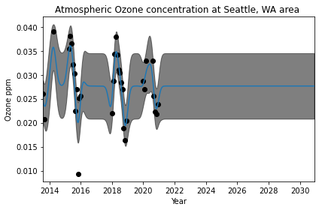

GPML kernel: 66**2 * RBF(length_scale=67) + 2.4**2 * RBF(length_scale=90) * ExpSineSquared(length_scale=1.3, periodicity=1) + 0.66**2 * RationalQuadratic(alpha=0.78, length_scale=1.2) + 0.18**2 * RBF(length_scale=0.134) + WhiteKernel(noise_level=0.0361)

Log-marginal-likelihood: -72.026

Learned kernel: 0.00316**2 * RBF(length_scale=101) + 0.00316**2 * RBF(length_scale=190) * ExpSineSquared(length_scale=9.76e+04, periodicity=0.166) + 0.492**2 * RationalQuadratic(alpha=16.9, length_scale=1e-05) + 0.866**2 * RBF(length_scale=0.173) + WhiteKernel(noise_level=0.0587)

Log-marginal-likelihood: -40.457

C:\Users\eveba\.conda\envs\Machine_Learning\lib\site-packages\sklearn\gaussian_process\kernels.py:402: ConvergenceWarning: The optimal value found for dimension 0 of parameter k1__k1__k1__k1__constant_value is close to the specified lower bound 1e-05. Decreasing the bound and calling fit again may find a better value.

warnings.warn("The optimal value found for "

C:\Users\eveba\.conda\envs\Machine_Learning\lib\site-packages\sklearn\gaussian_process\kernels.py:402: ConvergenceWarning: The optimal value found for dimension 0 of parameter k1__k1__k2__k1__k1__constant_value is close to the specified lower bound 1e-05. Decreasing the bound and calling fit again may find a better value.

warnings.warn("The optimal value found for "

C:\Users\eveba\.conda\envs\Machine_Learning\lib\site-packages\sklearn\gaussian_process\kernels.py:402: ConvergenceWarning: The optimal value found for dimension 0 of parameter k1__k2__k2__length_scale is close to the specified lower bound 1e-05. Decreasing the bound and calling fit again may find a better value.

warnings.warn("The optimal value found for "

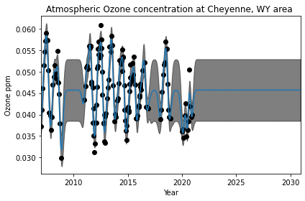

GPML kernel: 66**2 * RBF(length_scale=67) + 2.4**2 * RBF(length_scale=90) * ExpSineSquared(length_scale=1.3, periodicity=1) + 0.66**2 * RationalQuadratic(alpha=0.78, length_scale=1.2) + 0.18**2 * RBF(length_scale=0.134) + WhiteKernel(noise_level=0.0361)

Log-marginal-likelihood: -179.191

Learned kernel: 0.00316**2 * RBF(length_scale=1e+05) + 0.00316**2 * RBF(length_scale=1e+05) * ExpSineSquared(length_scale=0.335, periodicity=0.0545) + 0.97**2 * RationalQuadratic(alpha=390, length_scale=0.163) + 0.00316**2 * RBF(length_scale=0.0287) + WhiteKernel(noise_level=0.117)

Log-marginal-likelihood: -127.669

C:\Users\eveba\.conda\envs\Machine_Learning\lib\site-packages\sklearn\gaussian_process\kernels.py:402: ConvergenceWarning: The optimal value found for dimension 0 of parameter k1__k1__k1__k1__constant_value is close to the specified lower bound 1e-05. Decreasing the bound and calling fit again may find a better value.

warnings.warn("The optimal value found for "

C:\Users\eveba\.conda\envs\Machine_Learning\lib\site-packages\sklearn\gaussian_process\kernels.py:411: ConvergenceWarning: The optimal value found for dimension 0 of parameter k1__k1__k1__k2__length_scale is close to the specified upper bound 100000.0. Increasing the bound and calling fit again may find a better value.

warnings.warn("The optimal value found for "

C:\Users\eveba\.conda\envs\Machine_Learning\lib\site-packages\sklearn\gaussian_process\kernels.py:402: ConvergenceWarning: The optimal value found for dimension 0 of parameter k1__k1__k2__k1__k1__constant_value is close to the specified lower bound 1e-05. Decreasing the bound and calling fit again may find a better value.

warnings.warn("The optimal value found for "

C:\Users\eveba\.conda\envs\Machine_Learning\lib\site-packages\sklearn\gaussian_process\kernels.py:411: ConvergenceWarning: The optimal value found for dimension 0 of parameter k1__k1__k2__k1__k2__length_scale is close to the specified upper bound 100000.0. Increasing the bound and calling fit again may find a better value.

warnings.warn("The optimal value found for "

C:\Users\eveba\.conda\envs\Machine_Learning\lib\site-packages\sklearn\gaussian_process\kernels.py:402: ConvergenceWarning: The optimal value found for dimension 0 of parameter k2__k1__k1__constant_value is close to the specified lower bound 1e-05. Decreasing the bound and calling fit again may find a better value.

warnings.warn("The optimal value found for "